**User Guide for Minesweeper**

**Minesweeper UI**

here is the starting grid for a minesweeper game. This appears when mineseweeper is first opened, or when the reset button is pushed.

Click on any tile. This tile, and the surrounding 8 tiles are guaranteed to be dirt tiles (safe)

The program will designate these tiles as safe, and then populate the resto of the board with either a bomb or more dirt.

in this image, the first tile has been pressed, the board has been made, and the first tile was once again pressed (fired) by the program.

If a tile with 0 adjacent bombs is clicked (the first tile clicked is guaranteed to be this), all adjacent tiles will also be activated. And any adjacent tiles with 0 adjacent bombs will do the same – recursion.

Here you can see that by RIGHT CLICKING a tile, a flag is placed. Any tile with a flag cannot be activated until the flag is released. Flags are to represent where the user thinks a bomb is.

When a bomb is clicked, the rest of the bombs also fire.

The “Clear Board” button is used for debugging and or just curiosity. It reveals all tiles on the board by effectively activating all of them. For a consumer audience, this feature would not be available.

The ”Reset” button, as previously mentioned, resets the board.

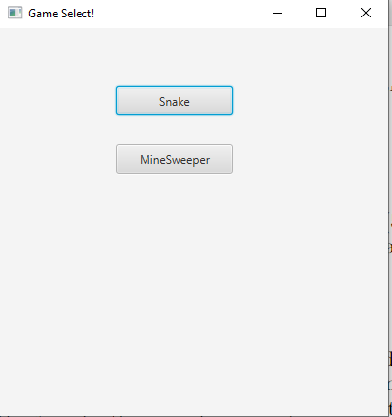

The “Back to Games” button brings the user back the game select screen.

**Debugging collaborators**

None. All the code for minesweeper was developed by Justin Davis.

**How to Play MineSweeper**

Minesweeper is a very popular computer game that has been around for decades meant to simulate digging in a minefield. With the goal of digging every square that is NOT a mine, otherwise, explosion.

In this program, there are DirtTiles and BombTiles. The user may not always know if a tile will be dirt or a bomb, as all unflipped tiles look the exact same, unless a flag is placed over a tile by right clicking.

Dirt tiles, when flipped, are all equipped with a number representing how many bombs are adjacent to said tile – however, “0” is never displayed, as that would be too much visual clutter.

If a tile with 0 adjacent tiles is clicked, all tiles directly beside it are also activated.

The goal – dig up (click) every tile that is not a bomb. If a bomb is pressed, the game is over.

Use the flag feature to help keep track of what you think is a bomb.

**Extras**

Minesweeper took me (Justin) an approximated 15-20 hours to complete. However, because of my limited experience, this number should be much lower for many experience programmers. In fact, I believe I could recreate this program in less than 4 hours, knowing what I know now, and having done it once before.

While not present in the pictures above, there is an emoticon at the top of the window. This emoticon will be used to show the win/currently-playing/loose condition.

._. currently playing

:) game is won

:( game is lost